Experiment # 3

Answer 1:

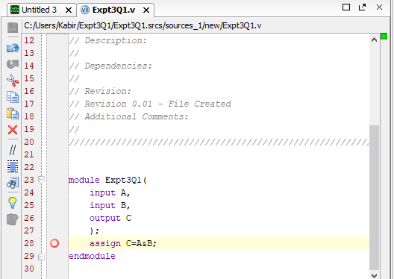
Module (Code)
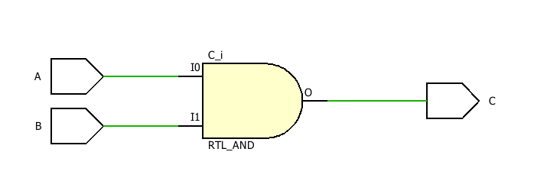
Schematic synthesis (Gate level)

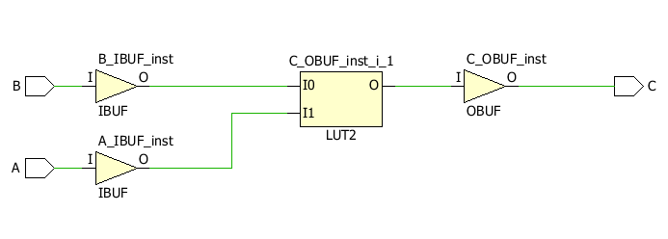
Schematic synthesis

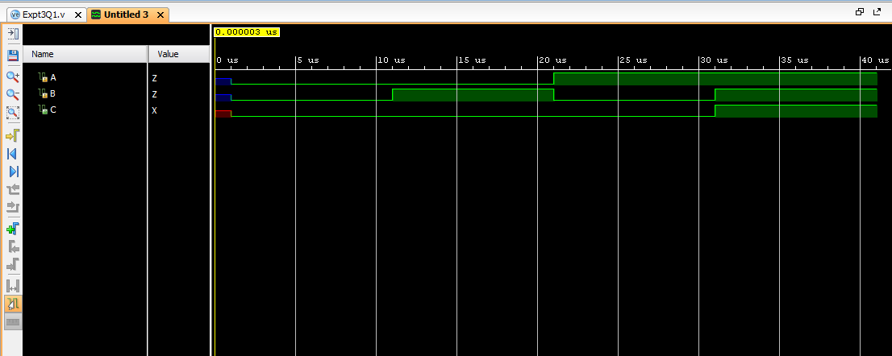
Output Waveform

Answer 2:

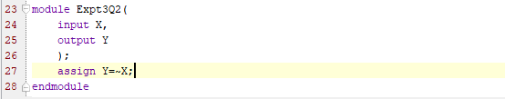
Module (Code)

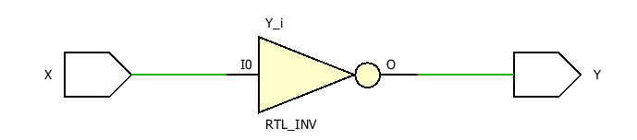
Schematic synthesis (Gate level)

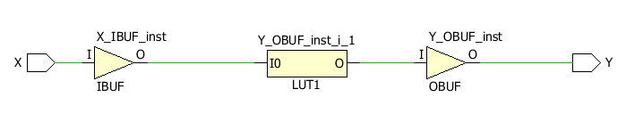
Schematic synthesis

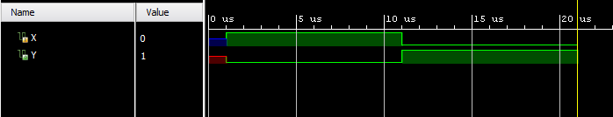
Output Waveform

Answer 3:

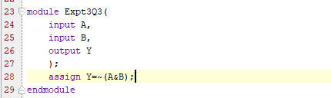
Module (Code)

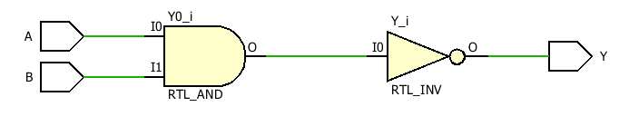
Schematic synthesis (Gate level)

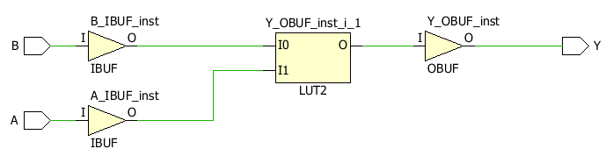
Schematic synthesis

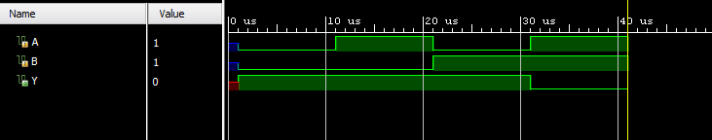
Output Waveform

Answer 4:

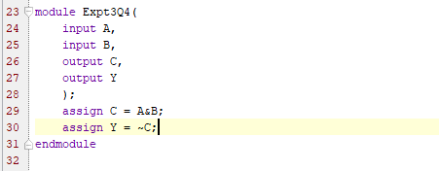
Module (Code)

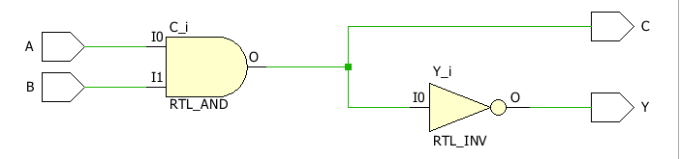
Schematic synthesis (Gate level)

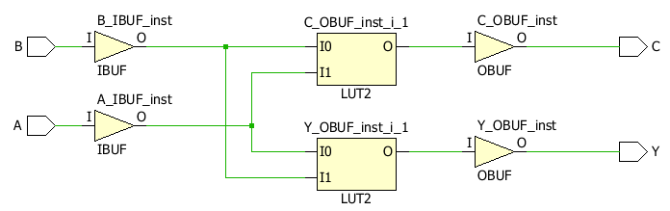
Schematic synthesis

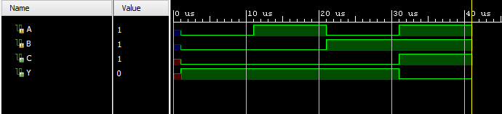
Output Waveform

Answer 5:
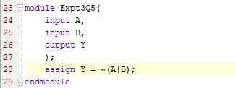
Module (Code)

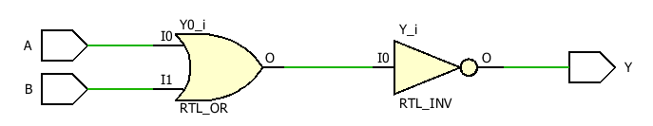
Schematic synthesis (Gate level)

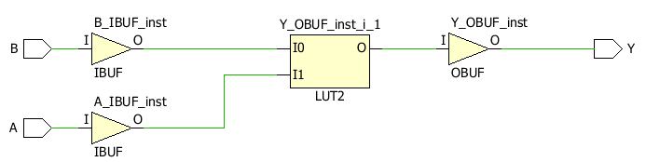
Schematic synthesis

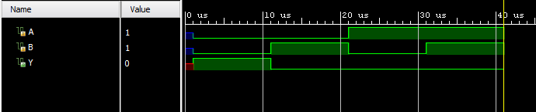
Output Waveform

Answer 6:
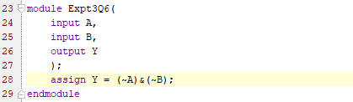
Module (Code)

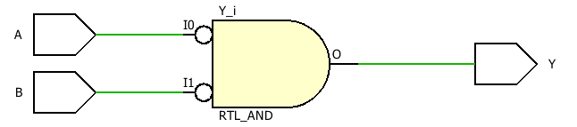
Schematic synthesis (Gate level)

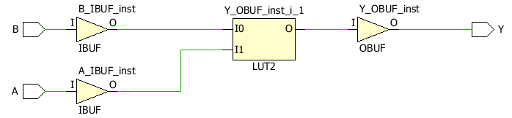
Schematic synthesis

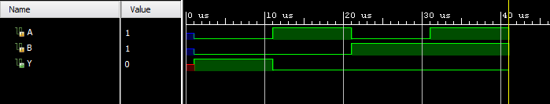
Output Waveform

  - NOTE: Therefore, we see that the output waveform is same for both parts (5) and (6).
  - This follows from Demorgan’s Law.

Answer 7:

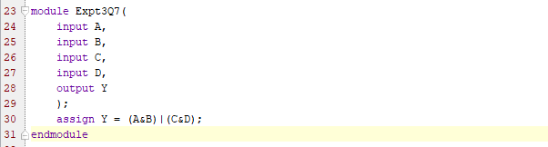
Module (Code)

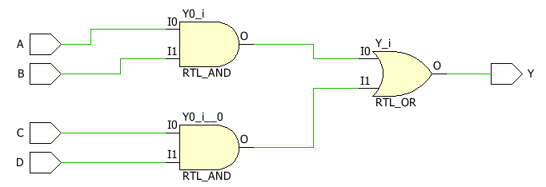
Schematic synthesis (Gate level)

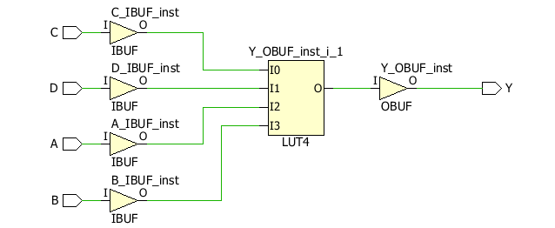
Schematic synthesis

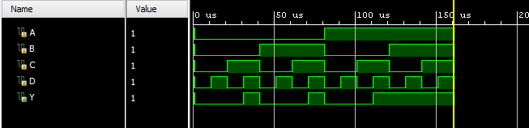
Output Waveform

Answer 8:

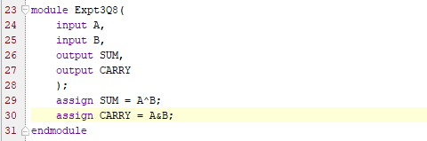
Module (Code)

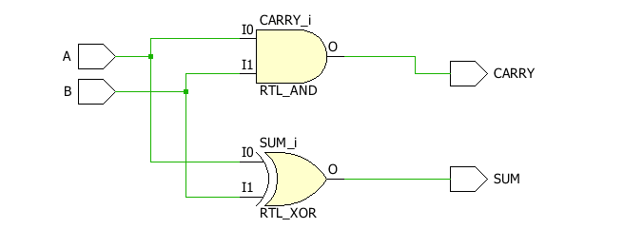
Schematic synthesis (Gate level)

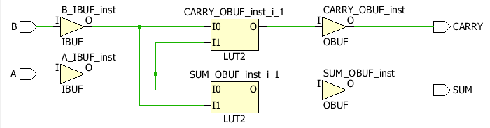
Schematic synthesis

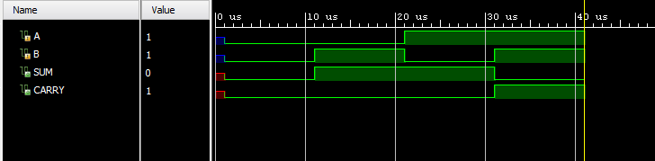
Output Waveform

Answer 9:

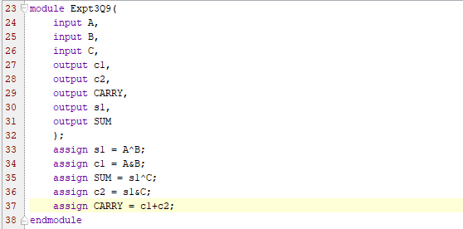
Module (Code)

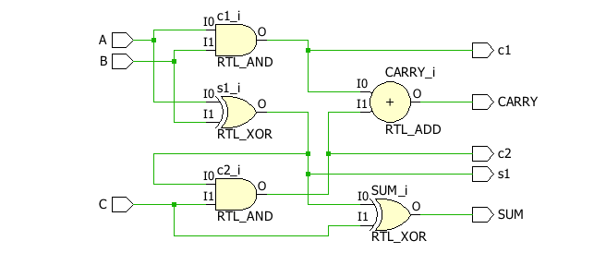
Schematic synthesis (Gate level)

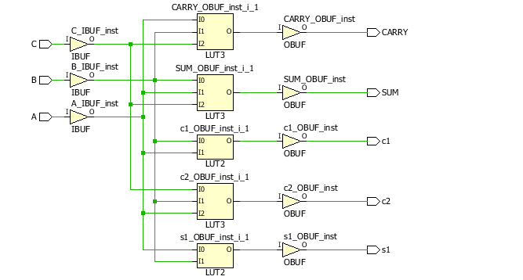
Schematic synthesis

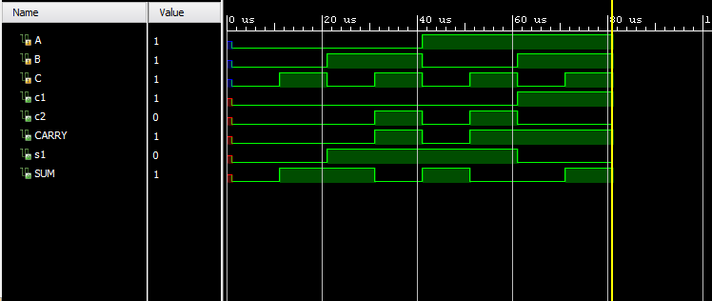
Output Waveform

